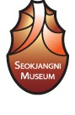
The 3rd Asian Paleolithic Association International Symposium
Gongju, Korea, 10 – 15 October 2010

About the Korean Palaeolithic Society (KPS)

The KPS is a nation-wide forum for practicing the Palaeolithic archaeology in Korea. Its aim is to exchange up-to-date Palaeolithic research, to promote interest and to encourage the exploration of various Palaeolithic issues.
The KPS publishes a biannual (June and December) Academic Journal called the “Journal of Korean Palaeolithic Society.” Annual conference is held at different place and various informal seminars are occasionally carried out.

The 3rd Asian Palaeolithic Association International Symposium

We are pleased to announce that the Korean Palaeolithic Society (KPS) is the host of the 3rd International Symposium of the Asian Palaeolithic Association (APA) on 10 Oct. 2010 (please refer http://www.kolithic.or.kr/). The forthcoming APA conference will cover a wide variety of popular topics relevant to the Asian Palaeolithic. All the major presentations will be held at Kongju National University, Gongju City, Korea where the renowned Seokjangni Palaeolithic site is located.

Topic
Main theme of the conference is ‘Diversity of the Asian Palaeolithic: Recent Progress and New Trends’.

The sub topics are as follows,
- Palaeo-environment of Asia
- Human behaviors and cultures in Asia
- Human evolution in Asia
- Special session: Palaeolithic culture in the Geum River Region (the annual KPS conference)
- Others

We are trying to expand the scope of the conference covering various issues. There is no particular limitation regarding the subject and the period as long as your topics are coherent with the Palaeolithic archaeology.

Registration (including call for paper)

We are happy to accept oral presentation (using ppt is preferred) or poster presentation during the conference. Official languages for conference presentations are English and Korean. If you consider either presentation, please send us an abstract (no more than 300 words) and choose one of particular sub topics you are going to participate in. The deadline of abstract submission is 30th July 2010.

Registration Fee
1. Registration Fee for 3 days Symposium:
It costs 250 USD per person. Accompanied person and graduate student is 150 USD. You can pay at the registration desk at the conference in Korea. The price covers accommodation and a registration kit including the abstract book, etc. Please note only cash payment will be accepted.

2. Registration Fee for Field Trip:
Three excursions will be proposed: Gangwon Province(A), Jeolla Province(B) and Chungcheong Province(C). The fee for the excursion will be 200 USD for professional participants and 150 USD for others.
Please check the attached map. Each excursion will be cancelled if the minimum number of participants is less than 10. Therefore, we recommend you to sign up the 1st and 2nd choices.

Excursion A (Coordinator : Dr. Seung-yup Choi)
Gongju→ Youngwol Ssang-gul→Yongwol Samok-ri Site→ Donghae Gigok Site → Mansang Site→ Wolso Site→ Chuncheon National Museum→ Yemaek Institute of Cultural Properties → Seoul

Excursion B (Coordinator :Prof. Gi-kil LEE)
Gongju→Jeonju/Wanju Innovation City Site→ Imsil Haga Site→ Honam Institute of Cultural Properties→Chosun University→Jangheung Sinbuk Site (Provincial Scheduled Monument No. 238) →Suncheon Wolpyung Site (National Scheduled Monument No. 458)→Songkwang Temple→Gwangju

Excursion C (Coordinator :Prof. Yung-jo LEE)
Gongju→Chungbuk National University Museum→Cheongju National Museum→Sangdang Fortress→Institute of Korean Prehistory→ChungjuJongdongri Prehistoric Site/Museum→Danyang Gunangul Site→Gosudonggul Cave→Suyanggae Site/ Museum→sight seeing of Eight Sceneries →Danyang

3. Accommodation:
The official conference hotel for accommodation is the Kumgang Hotel. Please specify your choice in the registration form.

Single Room (one bed): 40 USD per day
Standard Room A (one bed): 50 USD per day
Standard Room B (two beds): 50 USD per day

Time Table
1. Symposium
Day 1: 10 Oct. 2010— Registration (Parun Memorial Hall, Seokjangni Museum)
Day 2: 11 Oct. 2010— Presentations (Research Building, Kongju National University)
Day 3: 12 Oct. 2010
Morning session: Presentations (Research Building, Kongju National University)
Afternoon session: Visiting local historic places in Gongju City (Seokjangni site/ Museum etc.)
Day 4: 13rd 10 2010—Presentation (Research Building, Kongju National University)

The official conference begins on 11st Oct. 2010. However, we recommend you arrive a day prior to this date. The conference center is rather far from the Incheon international airport where you will be expected to arrive. It normally takes 2-3 hours to reach the Gongju city. Time can vary depending on the local traffic conditions.

2. Field Trip
Day 5: 14 Oct. 2010—Field Trip
Day 6: 15 Oct. 2010—Field Trip
Day 7: 16 Oct. 2010—Leaving

Information

Destination: Kongju National University (Gongju Singwan Campus), 182, Singwan-Dong, Gongju City, Korea

1) From Seoul by bus--
It takes one and a half hour to travel from Seoul Express Bus Terminal (Gyeongbu Line) to Gongju Bus Terminal by the express bus. From the Gongju Bus Terminal, it's a ten minutes walk to the KNU campus, or two minutes by taxi.

2) From Incheon International Airport--
From Incheon International Airport, we recommend you take the Airport Shuttle Bus to Daejeon, a major metropolitan city adjacent to Gongju. It takes two and half hours from Incheon to Daejeon. Our staff will welcome you at the Incheon International Airport and at the Daejeon Bus Depot.

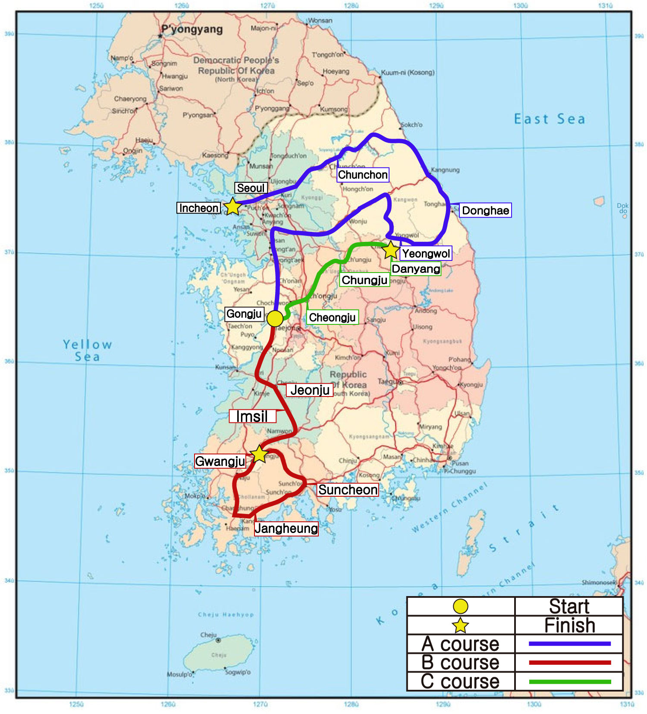

Contact
General Secretary: Dr. Su-jin KONG: Yonsei University Museum, Wonju, Korea, kongsj@yonsei.ac.kr

Financial Sponsors

Gong Ju City
Central Institute of Cultural Heritage
Honam Cultural Property Research Center
Chungcheong Cultural properties Research Institute
Chungcheongbuk do Cultural Heritage Research Foundation
Gyeore Institute of Cultural Heritage
HanBaek Research Institute for Cultural Heritage
HanGang Institute of Cultural Heritage
Institute of Korean Prehistory
Seokyeong Cultural Properties Research Institute

Registration Form

Please Complete (Type or print clearly)
Family Name: Given Name: Country:
Gender: Title:
Institution:
Mailing Address:
Telephone Fax: Email:

Please insert YES or NO before:
I want to receive the 3rd circular
I plan to attend the symposium
I plan to give an oral presentation
(If yes, provide the title of the presentation here)

I plan to give a poster presentation
I plan to join post-symposium excursion A(Gangwon Province course)
I plan to join post-symposium excursion B (Jeolla Province course)
I plan join post-symposium excursion C (Chungcheong Province course)

My presentation fits the following topic (insert YES after the session number below)
1. 2. 3. 4. 5.

Hotel Reservation (insert YES after your choice)

Single Room Standard Room A (one bed) Standard Room B (two beds)

Do you need a formal invitation form for your visa application?
If yes, please inform us the way you want to receive it (by fax, scanned and sent by e-mail, or original one sent by normal post).

